Texas A&M University-Commerce
Microsoft Outlook

How to add Signature:
- Go to “Home” < “New Email” < A new Window will Pop-Up
- Go to “Signature” < Click on “Signatures” from the drop down menu (a new pop-up will appear)
- Click on New and add signature as you like
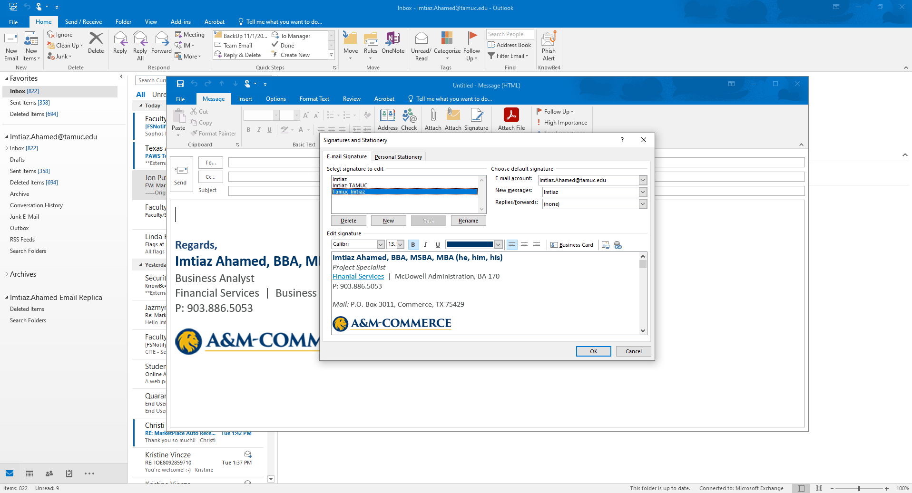

How to find TAMUC email directory for all Staff and Faculty:
- Go to “Home” < “New Email” < A new Window will Pop-Up
- Go to “To” (a new pop-up will appear), where we can search by Name.

